**Database Management Systems**

**CPS 430**

**Term Project**

**Inventory Management System**

**Himabindu Kurra**

**Shiva Sai Kanthala**

**Krishna Mullapudi**

**Vamshi Krishna Madaram**

**Vineetha Marikal**

**Introduction**

**Inventory management** software is a computer-based **system** for tracking **inventory** levels, orders, sales and deliveries. It can also be used in the manufacturing industry to create a work order, bill of materials and other production-related documents. Inventory is a list of items such as property, goods in stock, or contents of the building. In this project we explain about an inventory system which is used for dinning services. Our Inventory contains a list of food items used for dinning services.

**Entity Relationship Diagram**

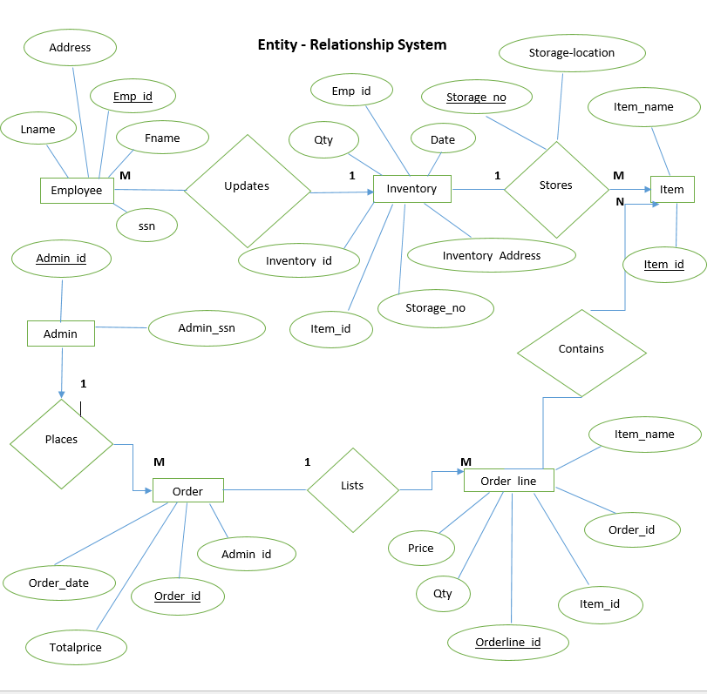

**Schema**

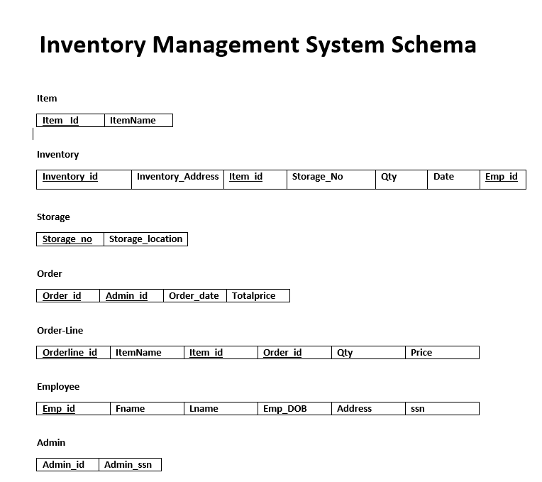

**Schema after Normalization**

**Admin**

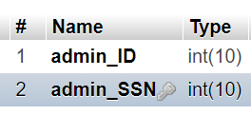

**Employee**

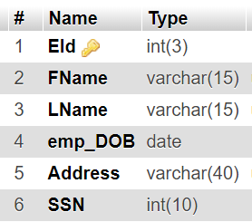

**Inventory**

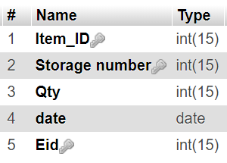

**Order**

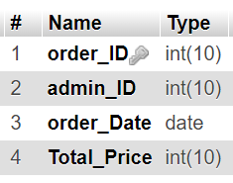

**Order List**

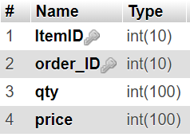

**Storage**

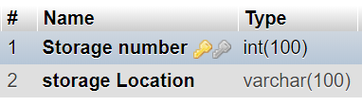

**Users**

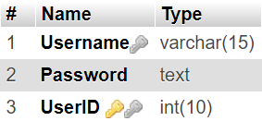

**Login Page**

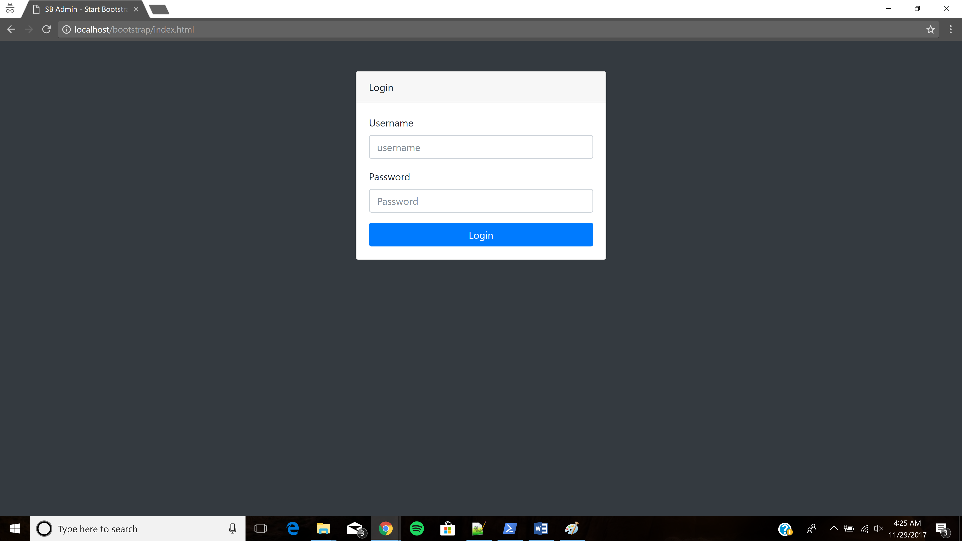

**Inventory**

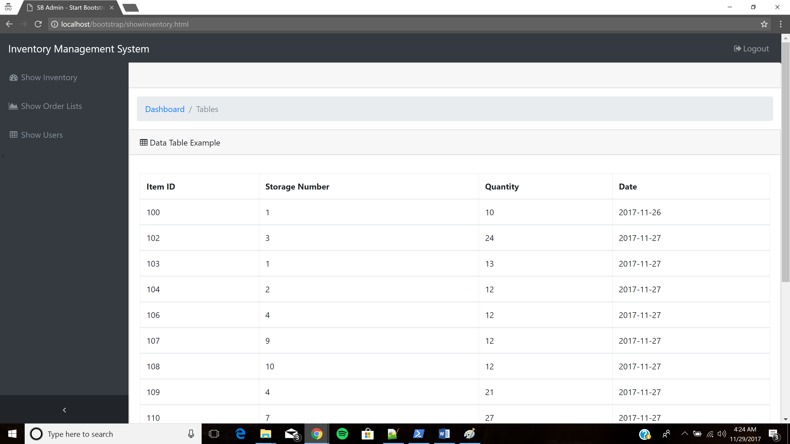

**Show Order List**

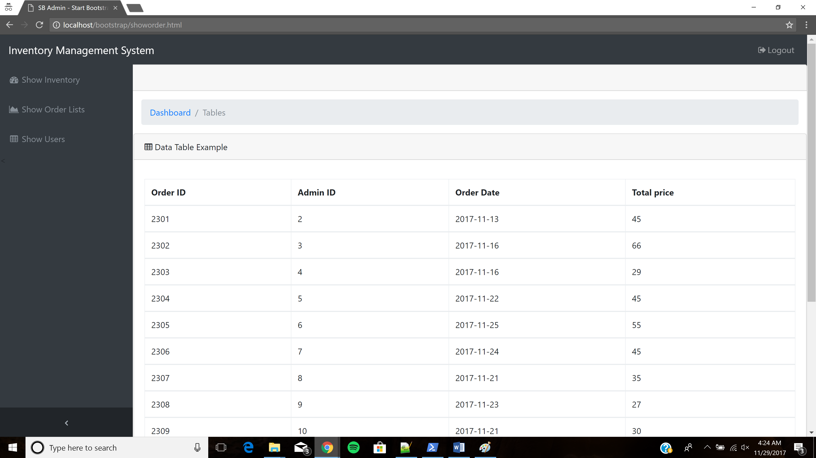

**Show Users**

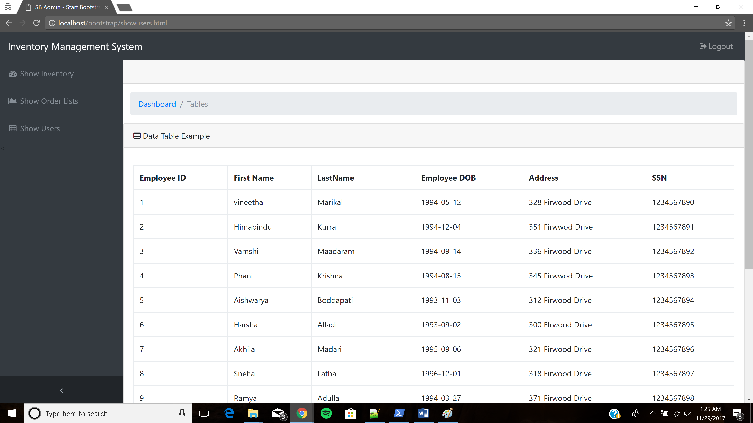

**Query1**

**List the names of the employees who have worked at the bakery**

**Select `Fname`,`Lname` FROM employee_list e, inventory i, storage s WHERE e.`Eid`=i.`EId` AND i.`Storage number`=s.`Storage number` AND s.`Storage Location`=”Bakery”**

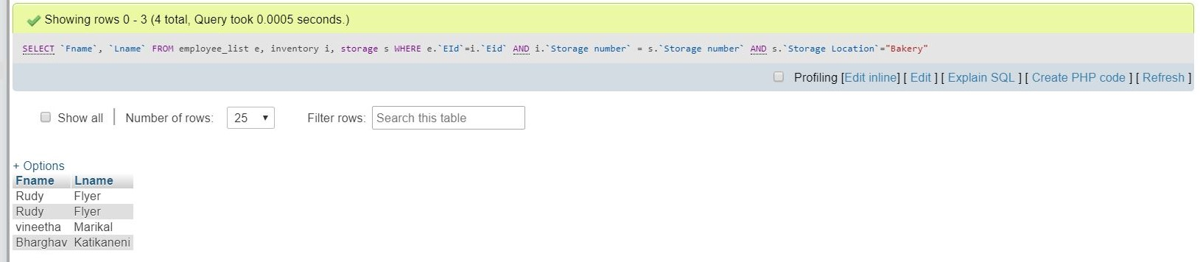

**Query2**

**SELECT `Fname`, `Lname` FROM employee_list, admin WHERE ` EId `=`admin_Id`**

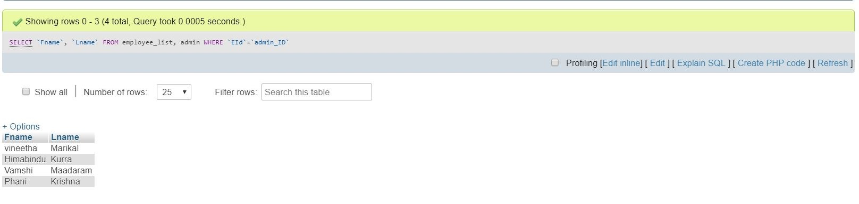

**Query3**

**List all the items whose quantity is greater than 10**

**SELECT Item_name, Qty FROM inventory, items WHERE `Item_ID`=`ItemID` AND `Qty`>10**

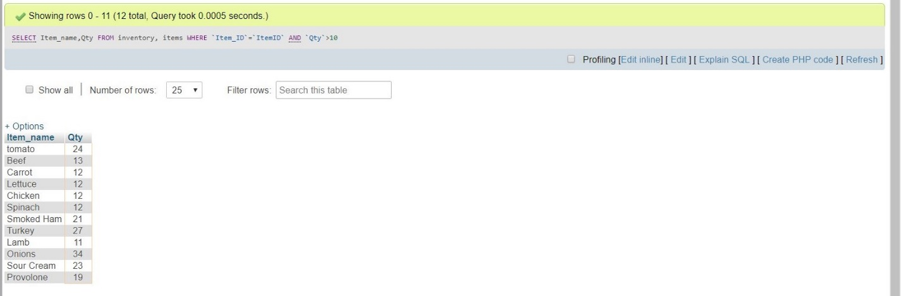

**Query 4**

**To insert an employee into Employee table**

**INSERT INTO `employee_list`, (`EId`, `Fname`, `Lname`, `emp_DOB`, `Address`, `SSN`) VALUES ( `16`, `Shiva` , `Kanathala`, `1992-09-29`,`340 Firwood Dr`,`2123423342`)**

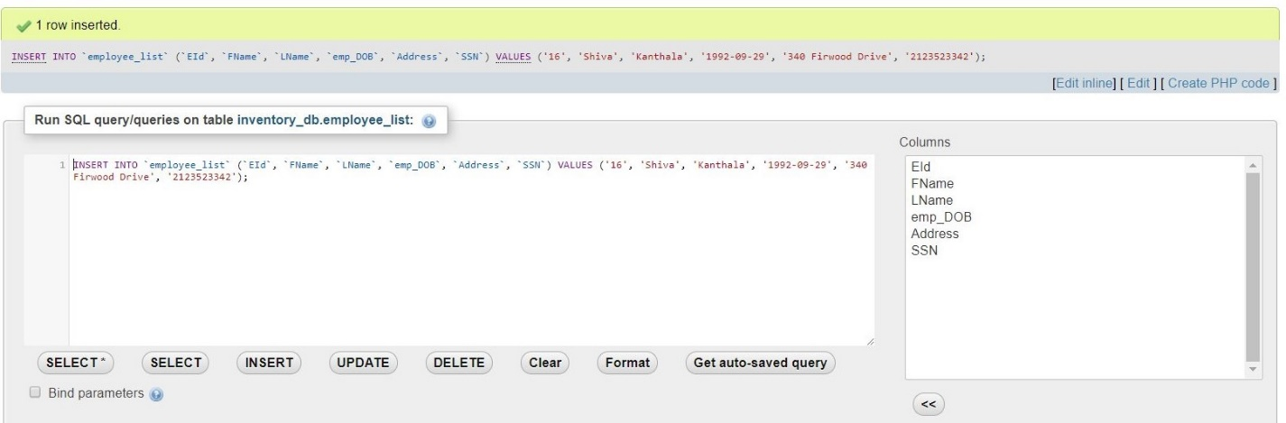

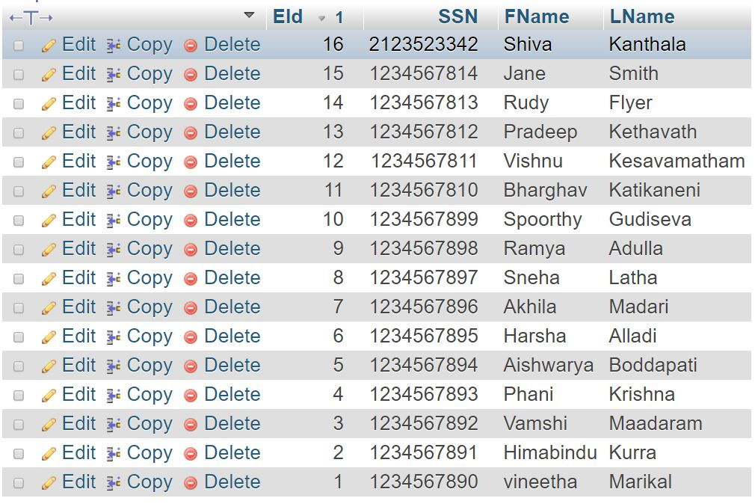

**Query5**

**CREATE A VIEW**

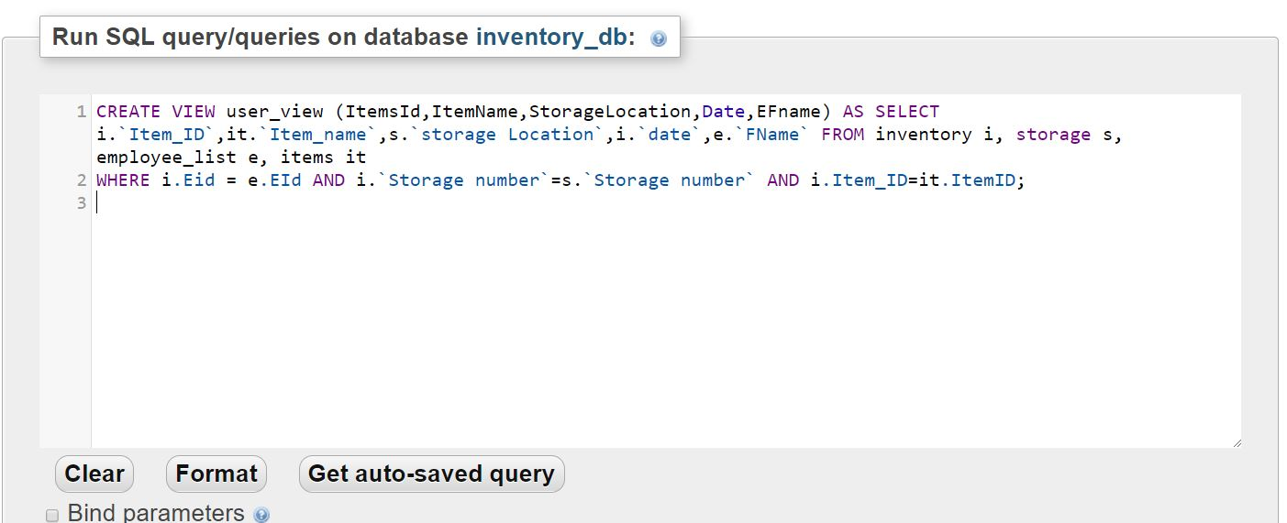

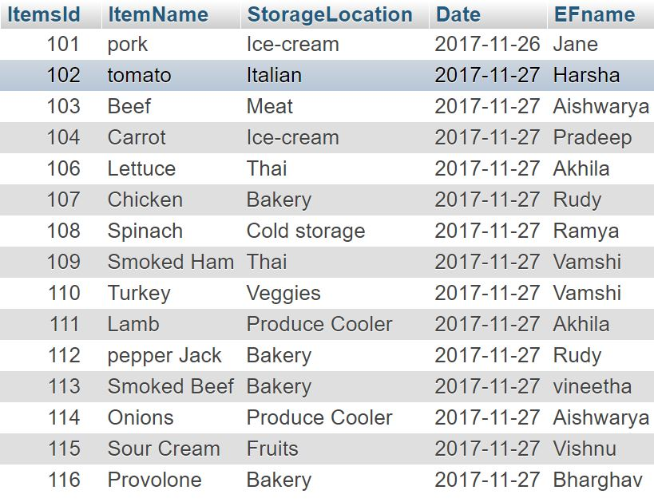

**Query6**

**List the items whose price range between 5 and 50**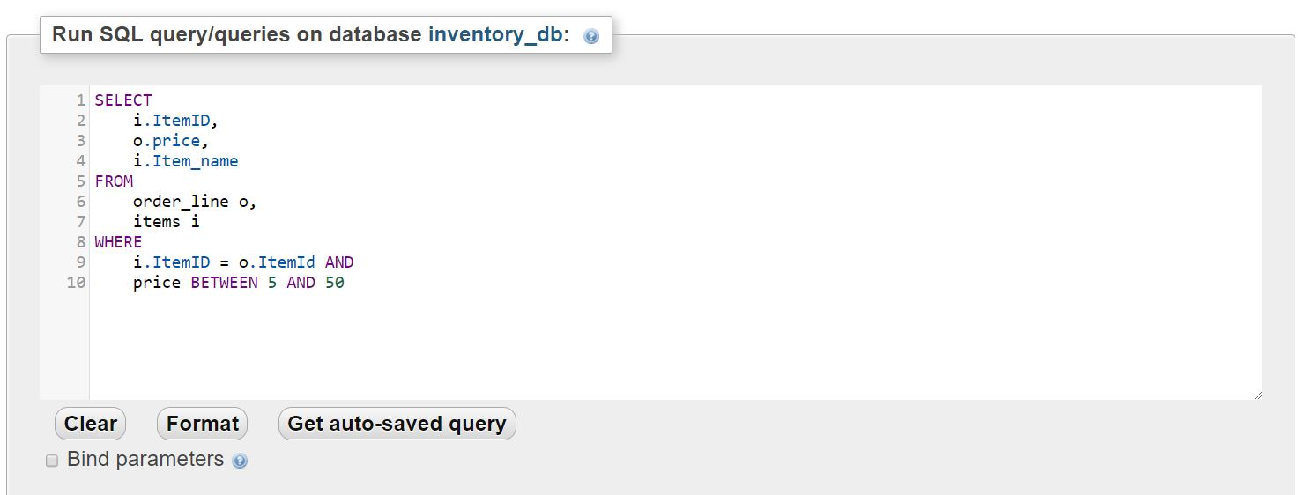

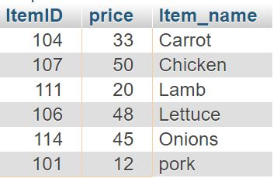

**Query7**

**To display Eid, SSN, Employee Names by using order by and group by**

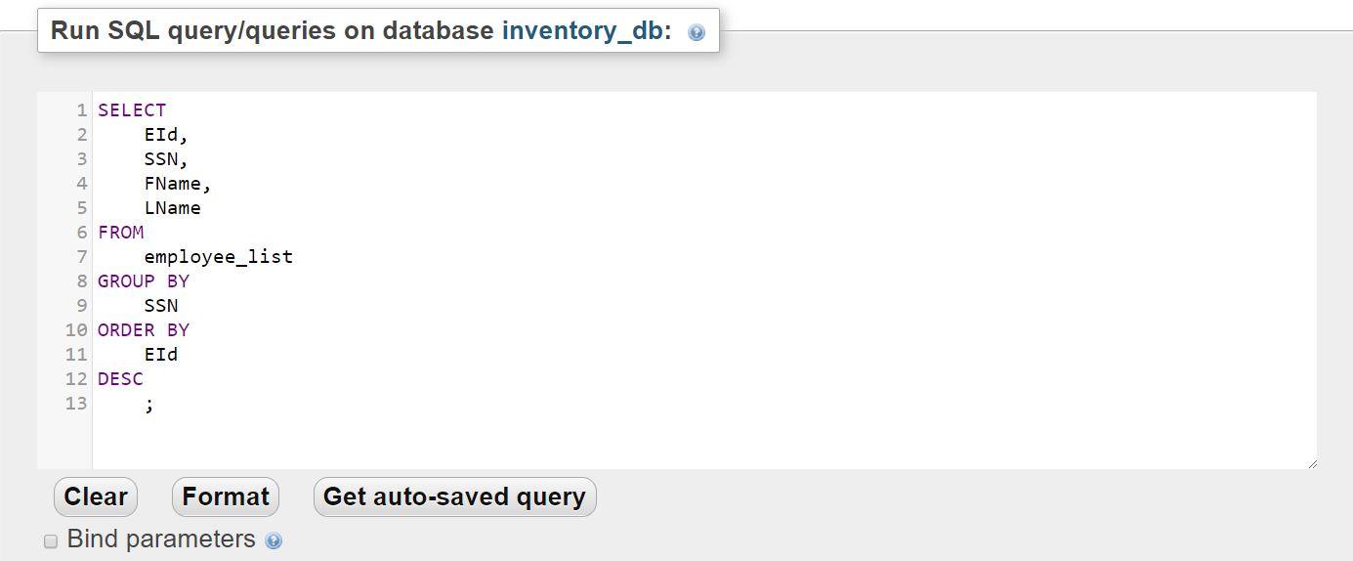



**Query8**

**List all the items that start with letter `S%`**

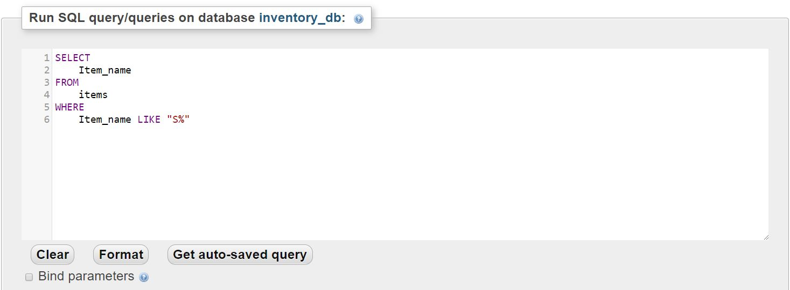

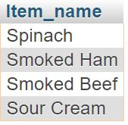

**Query 9**

**Update Employee Information**

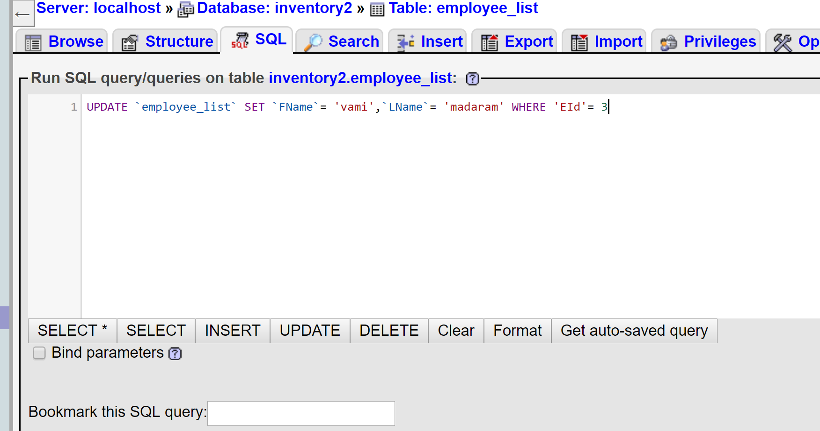

**Query10**

**Delete Employee information from the Employee Table**

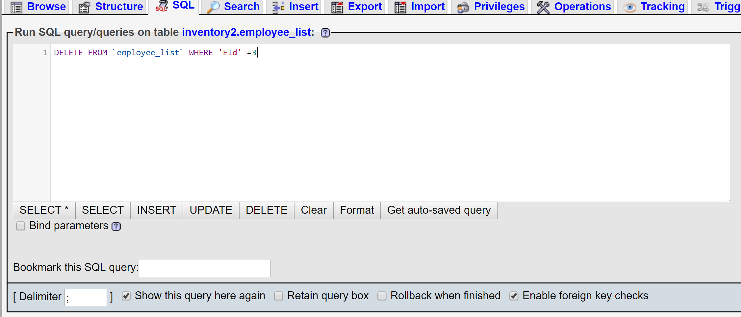

The link for the youtube video: <https://youtu.be/s2yZu-fizn0>